Sponsored By the Evangelical Network and The Northeast Jurisdiction Evangelical Connection

A Day Of Wesleyan Renewal
Keynote Speaker will be Bishop Mark Webb
Bishop Webb currently serves as the Episcopal Leader of the Upper New York Annual Conference. He holds a M. Div. from Asbury Theological Seminary and a Bachelor of Arts in Sociology from Shippensburg University. Bishop Webb encourages working together to develop strategies and outcomes that will bear fruit. He has a passion for leadership development, new faith communities and ensuring existing congregations grow in vitality and fulfill the mission of making disciples of Jesus Christ. Bishop Webb is a native of Williamsport, Pa., and is married to Jodi. They have two sons, Tyler and Benjamin.
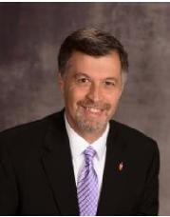
A Special Presentation of the Wesleyan Covenant Association by Rev. Dr. Joe Dipaolo
Rev. DiPaolo was born and raised in the New York City area, and holds degrees from Lafayette College, Palmer Seminary, and Princeton Seminary. While in college he had a life-changing encounter with Jesus Christ, and began a journey that led him into pastoral ministry. In 1988 he was ordained and became a clergy member of the Eastern Pennsylvania Conference (EPAC). His gifts for ministry include preaching, teaching and leading congregations to formulate new visions for ministry and outreach.
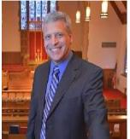
Breakout Sessions Led By:

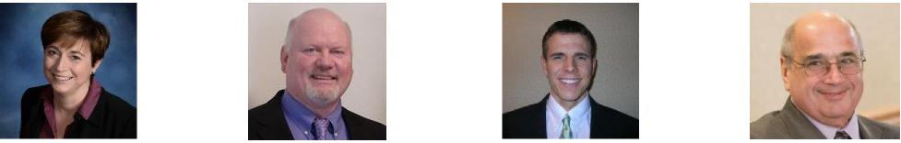

Rev. Cathy | Rev. Bruce | Rev. Dr. Ken | Rev. Chuck
Boileau | Fensterbush | Loyer | Sprenkle
“The Church Our | “Returning To Our | “Wesley’s Conception | “Explaining A National
Communities Need” | Evangelical Roots” | Of The Means Of Grace” | Debate to a Local
 |  |  | Congregation”

November 4th
9AM – 3PM
Crosspoint UMC
430 Colonial Rd, Harrisburg, PA 17109

Sponsored By the Evangelical Network and The Northeast Jurisdiction Evangelical Connection

A Day Of Wesleyan Renewal
Registration Form
(Registrations due by October 28th)
Name
Address
City State Zip
Phone Number
Email
Home Conference
Select One: Active Clergy Retired Clergy Laity
Dietary Needs: Vegetarian Gluten Free
Other (Describe)
Breakout Session #1 Choice
Breakout Session #2 Choice
Please email registration forms to jcopulos@susumc.org or mail to:
Rev. Jim Copulos
175 N Fairville Ave, Harrisburg, PA 17112
Registration Fee is $25 and can be made payable to NEJEC and
submitted the day of the event.
(*Note: The Registration Fee can be waived for those in financial need.
Please let us know if you need assistance.)

