Huntingdon Valley
United Methodist Church
Saturday, November 9, 2019
10:00AM – 4:00PM

9:00AM Doors Open, Gathering, Late Registration

10:00 AM Opening Worship

10:40 AM Session One

11:30 AM Break

11:50 AM Session Two

Lunch 12-1

1:45 PM Session Three

2:45 Session Four

3:00 PM Break

3:20 PM Closing Worship & Communion

4:00 PM Event Concludes

Register at - https://wesleyancovenant.org/Transformed/

Or see Pastor Dave or Pat for information

Cost to Register: $20.00

Cost for Lunch & Refreshments: Donation
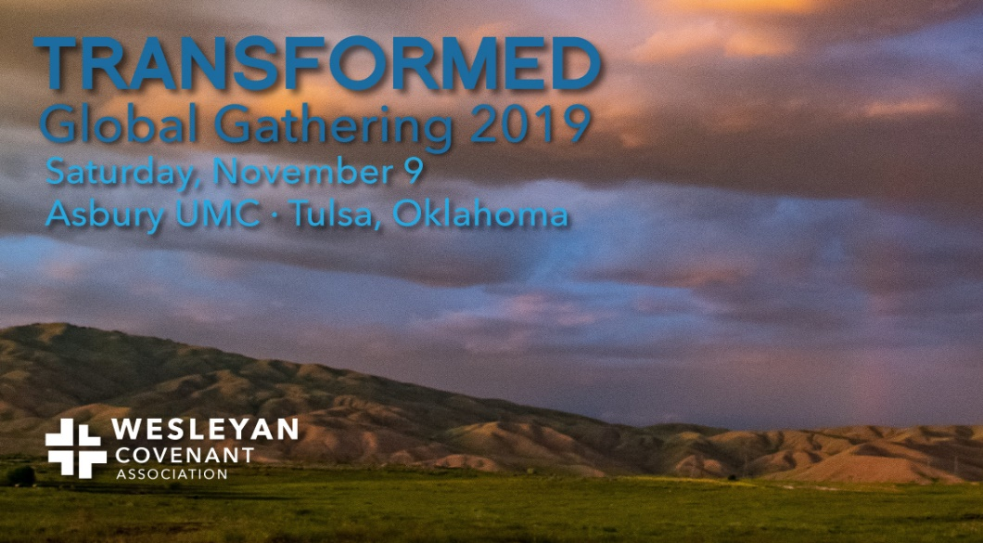

Huntingdon Valley

United Methodist Church

Saturday, November 9, 2019
10:00AM – 4:00PM

9:00AM Doors Open, Gathering, Late Registration

10:00 AM Opening Worship

10:40 AM Session One

11:30 AM Break

11:50 AM Session Two

Lunch 12-1

1:45 PM Session Three

2:45 Session Four

3:00 PM Break

3:20 PM Closing Worship & Communion

4:00 PM Event Concludes

Register at - https://wesleyancovenant.org/Transformed/

Or see Pastor Dave or Pat for information

Cost to Register: $20.00

Cost for Lunch & Refreshments: Donation

Speakers

William Abraham

Albert Cook Outler Professor Wesley Studies

Dallas, TX

Shane Bishop

Senior Pastor, Christ United Methodist Church

Fairview Heights, IL

Keith Boyette

President, Wesleyan Covenant Association

Fredericksburg, VA

Bob Kaylor

Lead Pastor, Tri-Lakes United Methodist Church

Monument, CO

Nako Kellum

Co-Pastor, Tarpon Springs FUMC

Tarpon Springs, FL

Kenneth Levingston

Senior Pastor, Jones Memorial UMC

Houston, TX

Cara Nicklas

Attorney - Oklahoma City, OK

Speakers

William Abraham

Albert Cook Outler Professor Wesley Studies

Dallas, TX

Shane Bishop

Senior Pastor, Christ United Methodist Church

Fairview Heights, IL

Keith Boyette

President, Wesleyan Covenant Association

Fredericksburg, VA

Bob Kaylor

Lead Pastor, Tri-Lakes United Methodist Church

Monument, CO

Nako Kellum

Co-Pastor, Tarpon Springs FUMC

Tarpon Springs, FL

Kenneth Levingston

Senior Pastor, Jones Memorial UMC

Houston, TX

Cara Nicklas

Attorney - Oklahoma City, OK

